EXPERIMENT-14
14) Perform Perspective Transformation on the given image using python and Open CV.
a)CODE
import cv2
import numpy as np
from tkinter import Tk, filedialog

root = Tk()
root.withdraw()

file = filedialog.askopenfilename(
title="Select Image",
filetypes=[("Image Files", "*.jpg *.jpeg *.png")]
)

img = cv2.imread(file)

if img is None:
print("Image not found")
else:
rows, cols = img.shape[:2]

pts1 = np.float32([
[50, 50],
[cols - 50, 50],
[50, rows - 50],
[cols - 50, rows - 50]
])

pts2 = np.float32([
[0, 0],
[cols, 50],
[50, rows],
[cols - 50, rows - 20]
])

matrix = cv2.getPerspectiveTransform(pts1, pts2)

transformed = cv2.warpPerspective(
img, matrix, (cols, rows)
)

cv2.imwrite(
r"C:\Users\Admin\Desktop\perspective_transformed.jpg",
transformed
)

cv2.imshow("Original Image", img)
cv2.imshow("Perspective Transformed Image", transformed)

print("Perspective transformation completed successfully")
print("Saved on Desktop as perspective_transformed.jpg")

cv2.waitKey(0)
cv2.destroyAllWindows()

b) INPUT
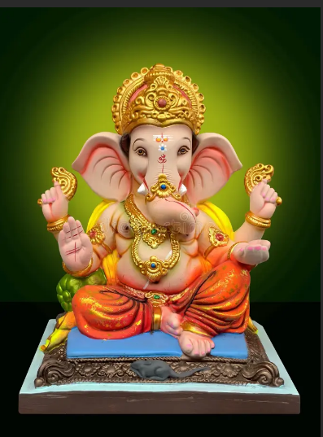
c) OUTPUT
